 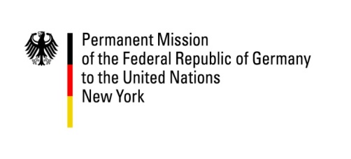  

Permanent Mission of the *Mission of Portugal to the United Nations*

Republic of Bulgaria to the UN

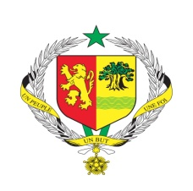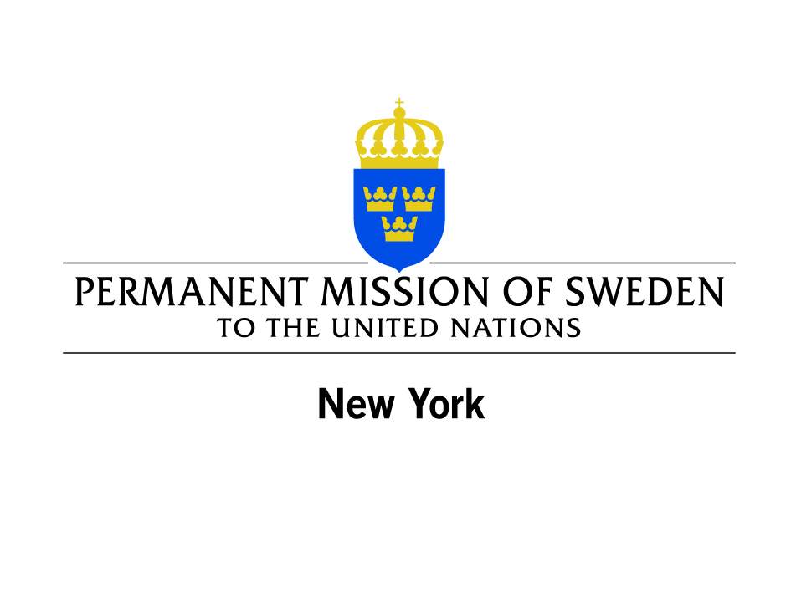 **

**STATEMENT BY THE GROUP OF FRIENDS OF YOUTH AT THE HIGH LEVEL OF THE GENERAL ASSEMBLY MARKING THE 20TH ANNIVERSARY OF THE WORLD PROGRAMME OF ACTION FOR YOUTH TO HIGHLIGHT YOUTH PRIORITIES IN THE POST-2015 DEVELOPMENT AGENDA**

**29 May 2015**

**New York**

Mr. Chair,

Distinguished delegates,

Ladies and Gentlemen,

I am making this statement on behalf of the Group of Friends on Youth and composed by the following countries: Bulgaria, Germany, Portugal, Republic of Moldova, Senegal, Sri Lanka and Sweden.

Let me begin by thanking the President of General Assembly for convening this timely event regarding the global youth agenda. The Group of Friends welcomes this initiative as a timely opportunity to renew the commitments made 20 years ago when the General Assembly adopted the World Programme of Action for Youth, which constitutes a comprehensive international strategy and guiding policy, in the area of youth development.

The World Programme of Action for Youth provides a policy framework and practical guidelines for national action and international support to improve the situation of young people. The range of challenges facing young people are directly related to the 15 priority areas of the World Programme of Action for Youth, namely, education, employment, hunger and poverty, health, environment, drug abuse, juvenile delinquency, leisure-time activities, girls and young women, full and effective participation of youth in the life of society and in decision-making, globalization, information and communications technology, HIV/AIDS, armed conflict and intergenerational issues.

Another aspect that we would like to underline is that the implementation of the WPAY requires the full enjoyment by all young people of all human rights and fundamental freedoms. Human Rights should, therefore, be the prerequisite to all considerations of policy involving youth.

We strongly believe that the WPAY and its 15 priority areas remain relevant for youth development and contain very concrete proposals for action at the national and international level. The Group of Friends reiterates its support for this document and for the implementation of its priority areas which are interlinked and mutually reinforcing.

Around the world, youth are drivers of social, political and economic change, claiming respect for fundamental rights and freedoms, improved living conditions for them and their communities, together with opportunities to learn, work and participate in decisions that affect them. More than ever, it is time to improve investment in research, policies and programmes to create an enabling environment for youth to prosper, fulfill their potential and enjoy their human rights, and engage as responsible social actors.

Young people are a major human resource for development and key agents for positive social change globally. Therefore full and sustainable youth participation in the elaboration of the post-2015 development agenda is thus essential. For that reason, a post-2015 framework should take into account the voices of young people so as to reflect their needs and aspirations for the future.

Young people cannot be perceived only as passive recipients of policies and programmes, but as fundamental partners in designing and implementing those policies and programmes and in sharing responsibilities as agents for a prosperous and peaceful future in our societies.

Thank you.